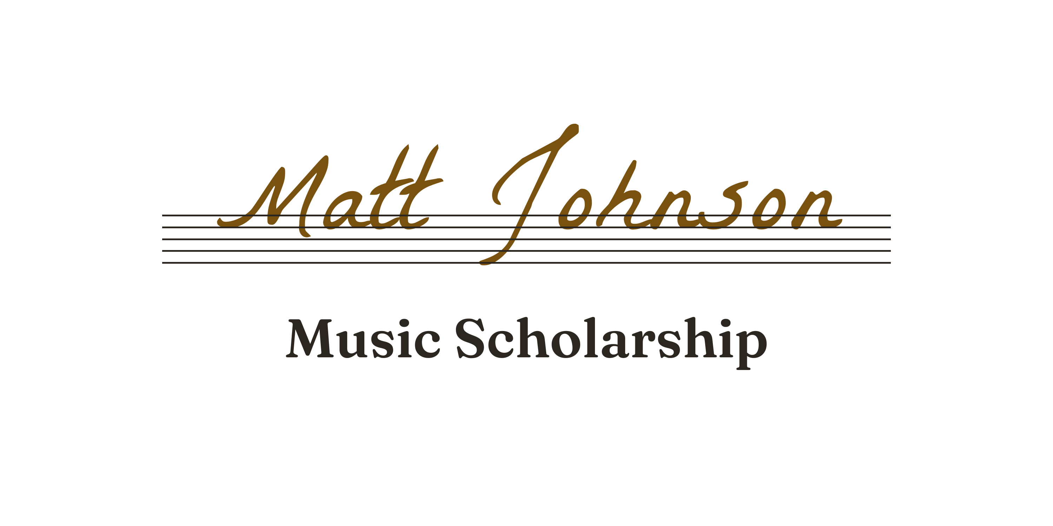
DIRECTIONS TO APPLY
ABOUT MATT AND THE FOUNDATION
Matt Johnson — our beloved son, brother, uncle, friend, and musician — passed away on September 1, 2016, at the age of 33. Matt loved music, and he loved sharing it with other people, especially young people. After his passing, generous donations from family and friends allowed us to create the Matt Johnson Music Foundation, so that his love of music can keep helping young people pursue their own.
Matt's talent was discovered early, when he began singing in his elementary school choir. He went on to become head chorister of the Columbus, GA Boys Choir and first-chair trumpet in the Harris County High School Marching Band. He later led the Atlanta rock band The Dirty Souls as lead vocalist, rhythm guitarist, and primary songwriter — performing regularly across Atlanta, recording, and earning radio play. Matt also taught music professionally, working with children learning to sing and to play guitar, ukulele, drums, and piano. His students performed at recitals, festivals, and open mic nights, because Matt believed the confidence it takes to perform for a live audience serves a young person in every part of life.
To honor Matt's passion and commitment to music, the Foundation presents an annual scholarship to a deserving graduating Harris County High School senior, former Harris County High School student, or former student of Matt's who shows that same spirit and love of music.
DUE DATE
Your application and video must be received by: ____________________ (also posted at mattjohnsonmusicfoundation.org/apply)
WHAT TO SUBMIT
Combine everything written below into ONE document (Microsoft Word or PDF), in this order:
- Cover page — your name, level of education (grade, or year in post-secondary training), your school (graduating seniors: include the school you plan to attend), email address, phone number, and home address.
- Music resume — your music training (band, chorus, private lessons — include the number of years), your instruments (voice counts), and your performances. Also include work experience and community service, especially anything involving music.
- Two one-page essays — one on each of these prompts:
- “Why I would like to receive the Matt Johnson Music Foundation Scholarship.”
- “The impact my music training has had on my decision about my future career.”
THE VIDEO
Record a short video (1–2 minutes) of yourself demonstrating your love of music — sing, or play an instrument. A cell phone recording is perfectly fine; we care about the playing, not the production. Email the video file along with your written document. If the file is too large to email, contact us at the address below and we will work it out.
FORMATTING
- Put your name at the top of every page.
- Essays: double-spaced, 1-inch margins, 12-point type in an easy-to-read font such as Arial or Times New Roman.
- Submit the written document as a Microsoft Word file or a PDF.
HOW TO SEND IT
Email your document and video to mattjohnsonmusicfoundation@gmail.com, with the document attached as one file titled with your name — for example: Music Scholarship application for Julie White.
Questions? Write to the same address. Every application is reviewed by Matt's family, friends, and former bandmates.

